# PROJECT REPORT

**DEEP LEARNING FUNDUS**

**IMAGE ANALYSIS FOR EARLY**

**DETECTION OF DIABETIC**

**RETINOPATHY**

***submitted by***

## PNT2022TMID27170

A.Abitha - 960219106009

N.Abirami - 960219106007

S.Affna - 960219106010

J.K.Ashini - 960219106039

# TABLE OF CONTENTS

## 1. INTRODUCTION 1

1.1 PROJECT OVERVI

1.2 PURPOSE

## 2. LITERATURE SURVEY 2

2.1 EXISTING PROBLEM 2 2.2 REFERENCES 2 2..3PROBLEM STATEMENT DEFINITION 5

## 3. IDEATION AND PROPOSED SOLUTION 6

3.1 EMPATHY MAP CANVAS 6 3.2 IDEATION & BRAINSTORMING 7 3.3 PROPOSED SOLUTION 8 3.4 PROBLEM SOLUTION FIT 9

## 4. REQUIREMENT ANALYSIS 10

4.1 FUNCTIONAL REQUIREMENTS 10 4.2 NON FUNCTIONAL REQUIREMENTS 11

## 5. PROJECT DESIGN 12

5.1 DATA FLOW DIAGRAM 12 5.2 SOLUTION & TECHNICALARCHITECTURE 13 5.3 USER STORIES 15

## 6. PROJECT PLANNING AND SCHEDULING 16

6.1 SPRINT PLANNING AND ESTIMATION 16 6.2 SPRINT DELIVERY SCHEDULE 17

**7. CODING & SOLUTIONING 18**

## 8. TESTING 20 8.1 TEST CASES 8.2 USER ACCEPTANCE TESTING

## 8.3 DEFECT ANALYSIS 22

8.4 TEST CASE ANALYSIS 22

## 9. RESULTS 23

9.1 PERFORMANCE METRICS 23

## 10. ADVANTAGES &DISADVANTAGES 24

10.1 ADVANTAGES 24

10.2 DISADVANTAGES

1. **CONCLUSION 25**

1. **FUTURE SCOPE**  26

## APPENDIX 27

SOURCE CODE 28

GITHUB 33

PROJECT DEMO 33

## CHAPTER 1 INTRODUCTION

**1.1Project Overview:**

Diabetic retinopathy is a diabetes complication that refers to retinal changes that occur in patients with diabetes mellitus. Diabetic retinopathy can develop in anyone who has type 1 or type 2 diabetes. Diabetic retinopathy is caused by damage to the small blood vessels of the light-sensitive tissue at the back of the eye called the retina and can lead to vision loss through several different pathways. It necessitates constant monitoring, and in the event of complications, it may shorten life expectancy. If it is not diagnosed and treated,it can blind you. The medication cannot cured at this time.

Diabetic retinopathy can be stopped or slowed down with treatment.

Diabetes management may be used carefully to treat mild cases.

**1.2 Project Overview:**

Diabetic Retinopathy {DB) is a complication of diabetes that influences the eyes. Damage to blood vessels in the tissue of the retina, the back layer of the eye ,typically causes it. Blurriness, floaters, dark or empty areas in the vision, and difficulty recognizing color blindness are some of the early symptoms. Diabetic retinopathy is one of the most common causes of sight loss among people of working age. You can have diabetic retinopathy and not know it. This is because it often has no symptoms in its early stages

**1.3 Purpose:**

The main purpose is it can control Blood sugar (glycemic control).Blood

Pressure Control—BP of less than 140/80 mm Hg for a patient with diabetes .Lipid Lowering—lowering LDL cholesterol through lifestyle modification. This changes the curvature of the lens, leading to changes in vision. However, once blood sugar levels are controlled, usually the lens will return to its original shape and vision improves. Patients with diabetes who can better control their blood sugar levels will slow the onset and progression of diabetic retinopathy.

## CHAPTER 2

**2.1 Literature Survey:**

It has 1200 images of the fundus and was divided into 580 images of normal and exudates for the project. The data set has been divided into two parts for the CN N process : the training dataset and the testing dataset. On 50% of the training dataset, this method achieve accuracy greater than 90%, and there maining 50% of the dataset is used for testing. The tests give an accuracy of about 85%.accuracy on the dataset of 80000 images .Diabetic retinopathy results from the damage diabetes causes to the small blood vessels located in the retina. These damaged blood vessels can cause vision loss:

* Fluid can leak into the macula, the area of the retina responsible for clear central vision. Although small, the macula is the part of the retina that allows us to see colors and fine detail. The fluid causes the macula to swell, resulting in blurred vision.
* In an attempt to improve blood circulation in the retina, new blood vessels may form on its surface. These fragile, abnormal blood vessels can leak blood into the back of the eye and block vision.

* 1. **Existing Problem:**

In this study, we have presented a systematic computational methodology for diabetic retinopathy and macular edema classification, and assessed its performance on a non-open dataset using five different diabetic retinopathy and macular edema classification systems. We have found that our deep learning model achieved comparable or better results with only a small fraction ( < 1/4) of training set images than used recently by two other groups to obtain the state-of-the-art results in the nonreferable/referable diabetic retinopathy (NRDR/RDR) classification, with similar model architecture. We have also presented state-of-the-art results for classifying retinal images using the proposed international diabetic retinopathy classification system (PIRC), when measured with Cohen’s quadratic-weighted kappa, using less than 2% of the images than previous state-of-the-art system. Our work also sets for the first time the baseline for classifying retinal images using the clinical scale of the proposed international macular edema classification system (PIMEC).

* 1. **Reference:**

Diabetes reduces life expectancy by five to 10 years. Premature cardiovascular disease is the most common cause of morbidity and mortality, but the microvascular complications specific to diabetes (box 1) are also contributory factors. Diabetes is the most common reason for renal replacement therapy worldwide, the most common cause of blindness in the under 65s, and the most common cause of non-traumatic amputation. With our current knowledge, most of these devastating events could be prevented or delayed, or their impact minimised. This review focuses on the prevention, early detection, and initial management of the vascular complications of diabetes in adults.

1. Marshall, S. M. & Flyvbjerg, A. Prevention and early detection of vascular complications of diabetes. *bmj.* **333**(7566), 475–480 (2006).

<http://www.adcis.net/en/Download-Third-Party/Messidor.html>.

2.Medical Research Act,

<https://www.finlex.fi/en/laki/kaannokset/1999/en19990488_20100794.pdf>

**2.4 Problem Statement Solution:**

In medical field, diagnosis of diseases competently carried out by using the image processing. Therefore, that to retrieve the relevant data from the amalgamation of resulting image is too difficult. Here the segmentation technique is very useful by semi supervised learning then the result can be tuned by using Deep Learning Neural Network. Deep neural networks have been investigated in learning latent representations of medical images, yet most of the studies limit their approach in a single supervised convolutional neural network (CNN), which usually rely heavily on a large scale annotated dataset for training. To learn image representations with less supervision involved, this problem can be solved using a deep CNN architecture that can be trained with only binary image pair information. Some researchers evaluated the learned image representations on a task of content-based medical image retrieval using a publicly available multiclass diabetic retinopathy fundus image dataset. The problem can be solved using deep CNN which requires much less supervision for training.

## CHAPTER 3 IDEATION AND PROPOSED SOLUTION

**3.1 Empathy Map Canvas**

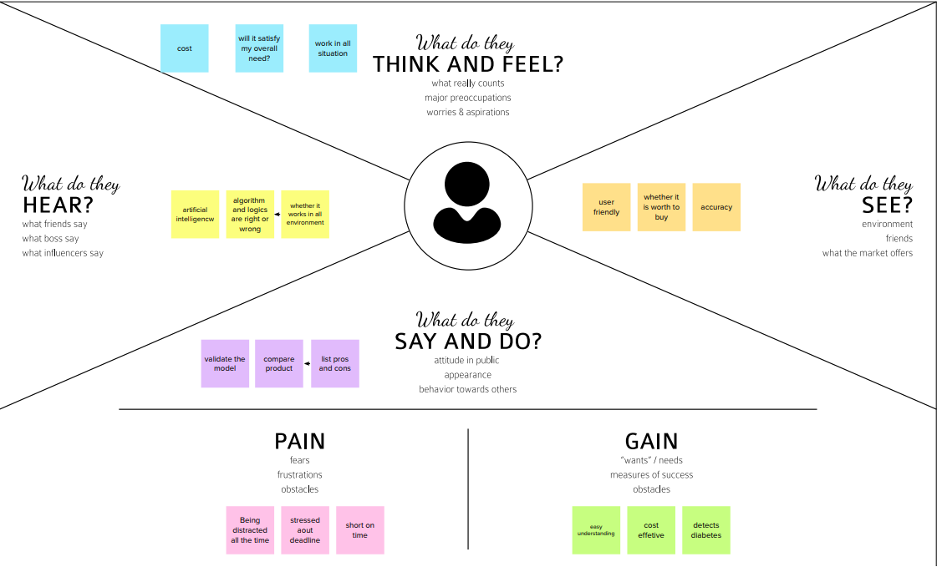

**3.2 IDEATION & BRAINSTROMING:**

Ideation is often closely related to the practice of brainstorming, a specific technique that is utilized to generate new ideas. A principal difference between ideation and brainstorming is that ideation is commonly more thought of as being an individual pursuit, while brainstorming is almost always a group activity. Brainstorming is usually conducted by getting a group of people together to come up with either general new ideas or ideas for solving a specific problem or dealing with a specific situation.

For example, a major corporation that recently learned it is the object of a major lawsuit may want to gather together top executives for a brainstorming session on how to publicly respond to the lawsuit being filed. Participants in a brainstorming session are encouraged to freely toss out whatever ideas may occur to them. The thinking is that by generating a large number of ideas, the brainstorming group is likely to come up with a suitable solution for whatever issue they are addressing .The lines between ideation and brainstorming have become a bit more blurred with the development of several brainstorming software programs, such as Bright idea and Idea wake. These software programs are designed to encourage employees of companies to generate new ideas for improving the companies’ operations and, ultimately, bottom-line profitability.

**3.3 Proposed Solution:**

A **problem statement** is a concise description of an issue to be addressed or a condition to be improved upon. It identifies the gap between the current (problem) state and desired

(goal) state of a process or product. The first condition of solving a problem is understanding the problem, which can be done by way of a problem state men

Idea solution is a progressive ,state of the art information technology .we have a proven track record of customer satisfaction with our clients ,ranging from residential client to small business to mid size corporations and government offices and agencies.

Idea solution is a progressive ,state of the art information technology .we have a proven track record of customer satisfaction with our clients ,ranging from residential client to small business to mid size corporations and government offices and agencies.

The purpose of this study is to test the relationship of perceived value, service quality and customer expectation with customer satisfaction. This study uses questionnaire method to collect data from the respondents.

**3.4 PROBLEM SOLUTION FIT:**

The Problem-Solution Fit simply means that you have found a problem with your customer and that the solution you have realized for it actually solves the customer’s problem. The Problem-Solution Fit canvas is based on the principles of Lean Startup, LUM (Lazy User Model) and User Experience design. It helps entrepreneurs, marketers and corporate innovators identify behavioral patterns and recognize what would work and why. It is a template to help identify solutions with higher chances of solution adoption, reduce time spent on testing and get a better overview of the current situation.My goal was to create a tool that translates a problem into a solution, taking into account customer behavior and the context around it. None of the existing canvases or frameworks were giving me an overview and insight into the real customer situation during his/her decision-making process. With this template you will be able to take important information into consideration at an earlier stage and look at problem solving in depth. It increases your chances of finding problem-solution and product-market fit.

## CHAPTER 4

**REQUIREMENT ANALYSIS**

**4.1 Functional Requirements:**

Following are the functional requirements of the proposed solution.

|  |  |  |  |  |
| --- | --- | --- | --- | --- |
| **FR No.** | **Functional Requirement**  **(Epic)** | **Sub Requirement (Story / Sub-Task)** | | |
| FR-1 | Deep learning |  | DL refers to methods learning the mathematical |  |
| representation of the latent and intrinsic relations of the data in an  automatic manner. Unlike traditional machine learning methods, deep  learning ones require much less human  guidance, since they are not |
| FR-2 | Neural network |  | The simplest form of a neural network refers to |  |
| an Articial Neural  Network (ANN), which consists of 3 layers of neurons, one input layer, one hidden layer and anal output lay |
| FR-3 | Traditional CNN |  | Convolutional Neural Networks (CNN), which |  |
| unlike shallow neural  networks accept 2D arrays as their input, were inspired by human vision  and their concept is based on a fundamental mathematical operation,  namely “convolution” |
| FR-4 | Transfer learning |  | Training a deep neural network is very |  |
| demanding in terms of  computational resources and data required. The world’s largest object  detection database, |
|  | Attention modules | It is well known that human vision and perception relies on attention  mechanisms to focus on specics parts of a scene or an object instead of processing the whole scene at once. | | |
|  | Generative Adversarial |  | Generative Adversarial Networks |  |
| Finally, another important class of convolutional neural networks  regards the Generative Adversarial Network (GAN) . |

**4.2 Non-functional Requirements:**

Following are the non-functional requirements of the proposed solution.

|  |  |  |
| --- | --- | --- |
| **FR No.** | **Non-**  **Functional**  **Requirement** | **Description** |
| NFR-  1 | **Usability** | Is has very use the diabetics |
| NFR-  2 | **Security** | To protect sensitive data, you may consider developing nonfunctional security features. For example, professionals at healthcare facilities use secure databases to store patients' medical records. The security on their databases may include firewalls to prevent unauthorized access. |
| NFR-  3 | **Reliability** | Technology that is highly reliable functions with the same or similar efficiency after extensive use. |
| NFR-  4 | **Performance** | Performance are classified into different types such as (a) response time, (b) throughput (number of operations performed per second) |
| NFR-  5 | **Availability** | Availability is defined as the Percentage of time that the system is up and running correctly |
| NFR-  6 | **Scalability** | Scalability is for large number of users or quantities of data |

# CHAPTER 5

**PROJECT DESIGN**

## 5.1 Data Flow Diagrams

A Data Flow Diagram(DFD) is a traditional visual the information flows within a system. A neat and clear DFD candepict the right amount of the system requirement graphically. It shows how data enters and leaves the system, what changes the information, and where data is stored.



RETINAL

FUNDUS

IMAGE

DATASET



FUNDUS

IMAGE



PRE-PROCESSING



FEATURE

EXTRACTION



DETECTION



DISEASE

CLASSIFICATION

STAGE



STOP

**5.2 Solution & Technical Architecture**

**Solution Architecture:**

Solution architecture is a complex process – with many sub-processes – that bridges the gap between business problems and technology solutions.

Its goals are to:

* 1. Find the best tech solution to solve existing business problems.
  2. Describe the structure, characteristics, behaviour, and other aspects of the software to project stakeholders.
  3. Define features, development phases, and solution requirements.
  4. Provide specifications according to which the solution is defined, managed, and delivered.

**Technologies needed for Minimum Viable Product deployment**

Software technologies required for the systematic development and deployment of the project are:

* 1. HTML/CSS/JavaScript/bootstrap-Front End Development
  2. Python
  3. Tensor Flow
  4. Image processing Basics
  5. Flask-Backend Development
  6. Git & GitHub-project Management
  7. IBM Cloud-Hosting
  8. IBM Watson-Training the Deep Learning Model

**SOLUTION- ARCHITECTURE DIAGRAM:**



**PREPROCESSING**

GREYSCALE

CONVERSION,NORMA

LIZATI-ON

CONSTRAST

LIMITED

ADAPTIVE

HISTOGRAM

EQUALIZATION,

GAMMA

**CONTRAST**

**ENHANCEMENT**

**(**

**GIF**

**)**

FEATURE

EXTRACTION

TRAINING

SAMPLES

NETWORK

TRAINING

DRU

(

NET)

DIMENSION

REDUCTON

PCA

(

)

XCEPTION-CNNARCHITE

CTURE

CLASSIFICATION

(

SYMPTOMS/NONSYMP

TOMS)

DATA

AUGMENTATION

TESTING

SAMPLES

TRAINING

IMAGES

UI

(

)

WEBPAGE

RETINOPATHY

NORMAL

**Reference: https://aws.amazon.com/blogs/industries/voice-applicationsinclinical-research-powered-by-ai-on-aws-part-1-architecture-anddesignconsiderations/**

**5.3 USER STORIES**

Use the below templateto list all the user stories for the product.

|  |  |  |  |  |  |  |
| --- | --- | --- | --- | --- | --- | --- |
| **User Type** | **Functional Requirement (Epic)** | **User**  **Story**  **Number** | **User Story / Task** | **Acceptance**  **criteria** | **Priori ty** | **Release** |
| Customer  (Mobile user) | Registration | USN-1 | As a user, I can check whether I have  Retinopathy or not by uploading the image of my eye by entering details. | I can upload or take image. | High | Sprint1 |
|  | Screening method | USN-2 | As a user ,I can find the method more  efficient and accurate. | It prevents the chances of unwanted infections in the patient’s eye | High | Sprint1 |
|  |  | USN-3 | As a user ,I can use it with minimal physical interaction with the device. | I can take the device to the residence of patients if they are unable to visit the hospital/clinic.  . | High | Sprint2 |
|  | Physical feature | USN-4 | As a user ,I can find it portable and light weight. | I can perform he screening procedure  without any fear and hesitation. | Low | Sprint2 |
|  | safety | USN-5 | As a user ,I can be safe as the detection method is free from radiations. | Pain due to testing is the major fear factor that prevents the patients from visiting the hospital. | High | Sprint4 |
| Custom  er (Diabetic Patient) | Testing | USN-6 | As a user ,I can undergo testing without any fear of pain as this method is pain-free. | Pain due to testing is the major fear factor that prevents the patients from visiting the hospital. | Medium | Sprint2 |
|  |  | USN-7 | As a user ,I will be  comfortable a sit requires  minimum/no human involvement. | The screening is carried out using a computer robot along with the aid of AI technology. | Low | Sprint-  4 |

|  |  |  |  |  |  |  |
| --- | --- | --- | --- | --- | --- | --- |
| **User Type** | **Functional**  **Requirement**  **(Epic)** | **User**  **Story**  **Number** | **User Story / Task** | **Acceptance**  **criteria** | **Priority** | **Release** |
|  | Results | USN-8 | As a user, I can rely on the results without any suspicion. | The technique is almost  100%  efficient as it involves  Modern techniques incorporated with Machine  Learning | High | Sprint-3 |
|  |  | USN-9 | As a user, I can benefit from the result as it  will help me know whether treatment is necessary or not. | It can prevent me from vision loss. | High | Sprint-1 |
|  |  | USN-10 | As a user, I can get the results on the spot immediately after the screening process. | It prevents further delay  in the treatment process. | Low | Sprint-4 |
| Customer  (Public  Sector/Priva  te  Sector) | Cost  Efficiency | USN-11 | As a  user, I can reach many people suffering from  diabetes. | Diabetic patients are more vulnerable to Diabetic Retinopathy. | Medium | Sprint-1 |

|  |  |  |  |  |  |  |
| --- | --- | --- | --- | --- | --- | --- |
|  |  | USN-12 | As a user, I can create awareness among diabetic patients to undergo frequent screening. | As the technique is of low cost, patients will find it very useful. | Low | Sprint-3 |
|  | Results | USN-13 | As a user, I can complete the screening process within minutes for a single patient. | The random results generated by the device saves time. | High | Sprint-2 |

## CHAPTER 6

**PROJECT PLANNING AND SCHEDULING**

**6.1 SPRINT PLANNINGAND ESTIMATION**

|  |  |  |  |  |
| --- | --- | --- | --- | --- |
| SPRINT | USER STORY / TASK | STORY  POIN TS | PRIORITY | TEAM MEMBERS |
| Sprint - l | Get the dataset | 3 | High | A.Abitha,N.Abirami,  S.Affna,J.K.Abirami |
| Explore the data | 2 | Medium | A.Abitha,N.Abirami,  S.Affna,J.K.Abirami |
| Data Pre-Processing | 3 | High | A.Abitha,N.Abirami,  S.Affna,J.K.Abirami |
| Prepare training and testing data | 3 | High | A.Abitha,N.Abirami,  S.Affna,J.K.Abirami |
| Sprint - ll | Create the model | 3 | High | A.Abitha,N.Abirami,  S.Affna,J.K.Abirami |
| Train the model | 3 | High | A.Abitha,N.Abirami,  S.Affna,J.K.Abirami |
| Test the model | 3 | High | A.Abitha,N.Abirami,  S.Affna,J.K.Abirami |
| Sprint - lll | Improve the model | 2 | Medium | A.Abitha,N.Abirami,  S.Affna,J.K.Abirami |
| Setup a database to store  inputimages | 2 | Medium | A.Abitha,N.Abirami,  S.Affna,J.K.Abirami |
| Sprint - IV | Build the results page | 3 | High | A.Abitha,N.Abirami,  S.Affna,J.K.Abirami |

|  |  |  |  |  |  |
| --- | --- | --- | --- | --- | --- |
|  | Save the model | 3 |  | High |  |
| Build the Home Page |  | 3 | High | A.Abitha,N.Abirami,  S.Affna,J.K.Abirami |
| Integrate the model with the application |  | 3 | High | A.Abitha,N.Abirami,  S.Affna,J.K.Abirami |
| Test the application |  | 3 | High | A.Abitha,N.Abirami,  S.Affna,J.K.Abirami |

**6.2 SPRINT DELIVERY SCHEDULE**

|  |  |  |  |  |  |  |
| --- | --- | --- | --- | --- | --- | --- |
| **SPRINT** | **TOTAL**  **STORY**  **POINTS** | **DURATION** | **SPRINT**  **START DATE** | **SPRINT END**  **DATE**  **(PLANNED)** | **STORY**  **POINTSCOMPLET**  **ED (AS ON PLANNED DATE)** | **SPRINT**  **RELEASE DATE**  **(ACTUAL)** |
| Sprint - I | 11 | 6 Days | 24 Oct  2022 | 29 Oct  2022 | 11 | 29 Oct  2022 |
| Sprint -  II | 9 | 6 Days | 31 Oct  2022 | 05 Nov  2022 | 9 | 05 Nov  2022 |
| Sprint -  III | 10 | 6 Days | 07 Oct  2022 | 12 Nov  2022 | 10 | 12 Nov  2022 |
| Sprint - IV | 9 | 6 Days | 14 Nov  2022 | 19 Nov  2022 | 9 | 19 Nov  2022 |

**CHAPTER 7**

## CODING AND SOLUTIONING

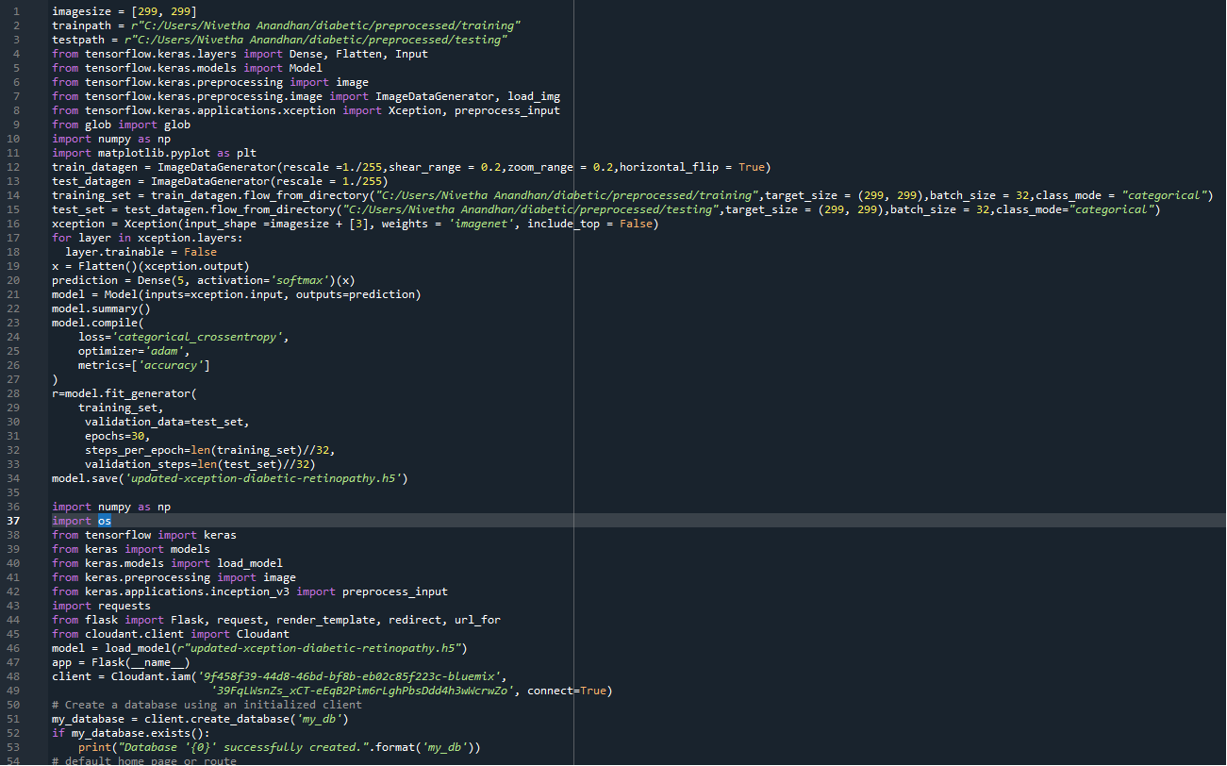

## CHAPTER 8

**TESTING**

**8.1 TEST CASES:**

|  |  |  |  |  |  |  |
| --- | --- | --- | --- | --- | --- | --- |
| Test case  ID | Feature  Type | Component | Test  Scenario | Expected Result | Actual Result | Status |
| HP_TC_001 | UI | Home Page | Verify UI elements in the  Home Page | The Home page must be  displayed properly | Working as expected | PASS |
| HP_TC_002 | UI | Home Page | Check if the  UI elements are displayed  properly in different screen sizes | The Home page must be  displayed  properly in all sizes | The UI is not displayed  properly in  screen size  2560 x 1801 and 768 x 630 | FAIL |
| HP_TC_003 | Functional | Home Page | Check if user can upload their file | The input image should be  uploaded to the application successfully | Working as expected | PASS |
| HP_TC_004 | Functional | Home Page | Check if user cannot upload  unsupported  files | The application  should not allow user to  select a non image file | User is able double load any  file | FAIL |
| HP_TC_005 | Functional | Home Page | Check if the page  Redirects to the  result page once the input is given | The page should redirect to the results page | Working as expected | PASS |

|  |  |  |  |  |  |  |
| --- | --- | --- | --- | --- | --- | --- |
| BE_TC_001 | Functional | Backend | Check if all the routes are working properly | All the routes should properly work | Working as expected | PASS |
| M_TC_001 | Functional | Model | Check if the model can  handle various image sizes | The model should rescale the  Image and predict the results | Working as expected | PASS |
| M_TC_002 | Functional | Model | Check if the model  predicts the digit | The model should predict the number | Working as expected | PASS |
| M_TC_003 | Functional | Model | Check if the model can handle  complex input image | The model should predict the  number in the complex image | The model fails to identify the  digit since the  model is not built to  handle such data | FAIL |
| RP_TC_001 | UI | Result Page | Verify UI elements in  the Result  Page | The Result page must be displayed properly | Working as expected | PASS |
| RP_TC_002 | UI | Result Page | Check if the input image is displayed properly | The input image should be  displayed properly | The size of the input image  exceeds the display container | FAIL |
| RP_TC_004 | UI | Result Page | Check if the other  predictions  are displayed properly | The other predictions should be displayed properly | Working as expected | PASS |

**CHAPTER 9** **PERFORMANCE TESTING:**

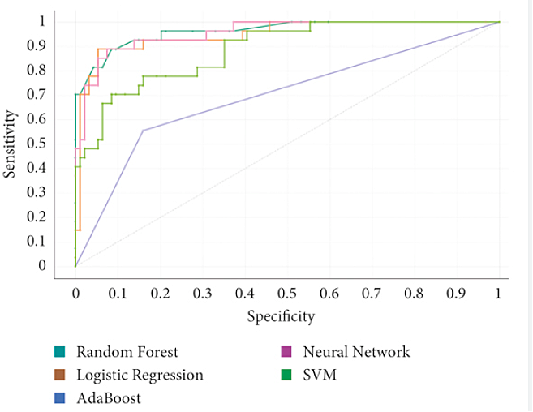

### CHAPTER 10

**ADVANTAGES & DISADVANTAGES**

**ADVANTAGES**

i. Reduces manual work ii. More accurate than average human iii. Capable of handling a lot of data iv. Can be used anywhere from any device

**DISADVANTAGES**

v. Cannot handle complex data vi. All the data must be in digital format vii. Requires a high performance server for faster predictions viii. Prone to occasional errors

**CHAPTER 11**

**CONCLUSION**

Diabetic retinopathy is a serious [complication of diabetes mellitus](https://www.sciencedirect.com/topics/medicine-and-dentistry/complications-of-diabetes-mellitus), leading to progressive damage and even blindness of the retina. Its early detection and treatment is important in order to prevent its deterioration and the [retina's damage](https://www.sciencedirect.com/topics/medicine-and-dentistry/retina-injury). The interest in applying deep learning in detecting diabetic retinopathy has increased during the past years and as several DL systems evolve and become integrated into the clinical practice, they will enable the clinicians to treat the patients in need more effectively and efficiently. This article presents the current state of research regarding the application of deep learning in diagnosing diabetic retinopathy. Although deep learning has paved the way for more accurate diagnosis and treatment, further improvements are still necessary regarding performance, interpretability and trustworthiness from ophthalmologists.

**CHAPTER 12**

### FUTURE SCOPE

This project is far from complete and there is a lot of room for improvement.

Some of the improvements that can be made to this project as follows:

* Add support to detect from digits multiple images and

save the results

* Add support to detect multiple digits

* Improve model to detect digits from complex images

* Add support to different languages to help users from all over

the world.

This project has endless potential and can always be enhanced to become

better .Implementing this concept in the real world will benefit several

industries and reduce the workload on many workers, enhancing overall work efficiency.

### APPENDIX

**SOURCE CODE**

**INDEX.HTML**

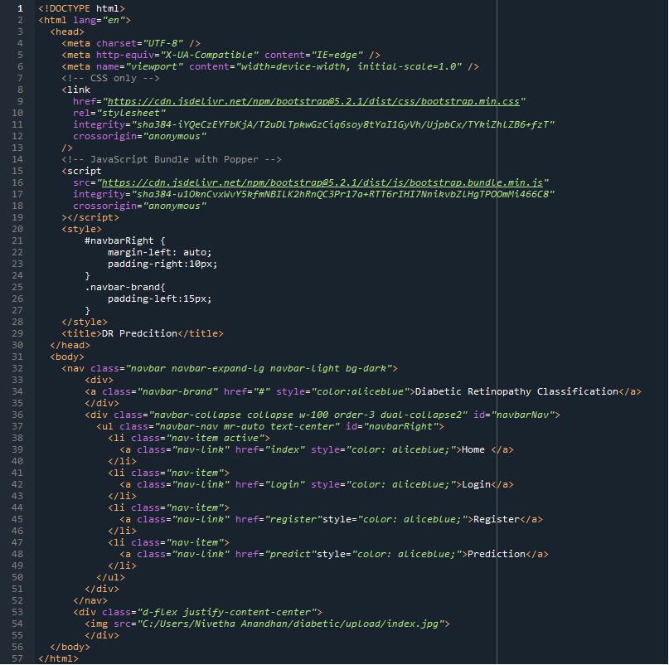

**REGISTER.HTML:**

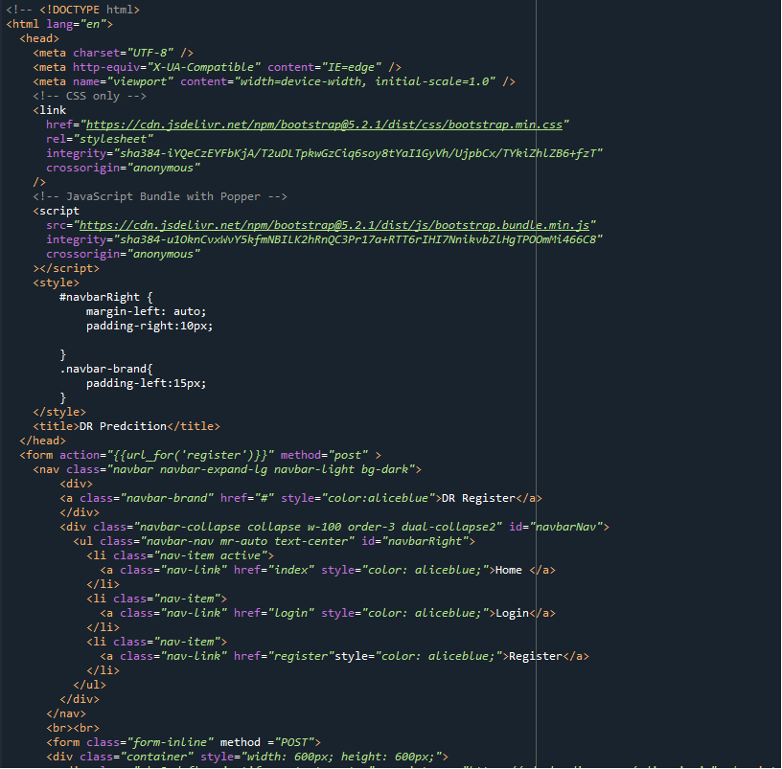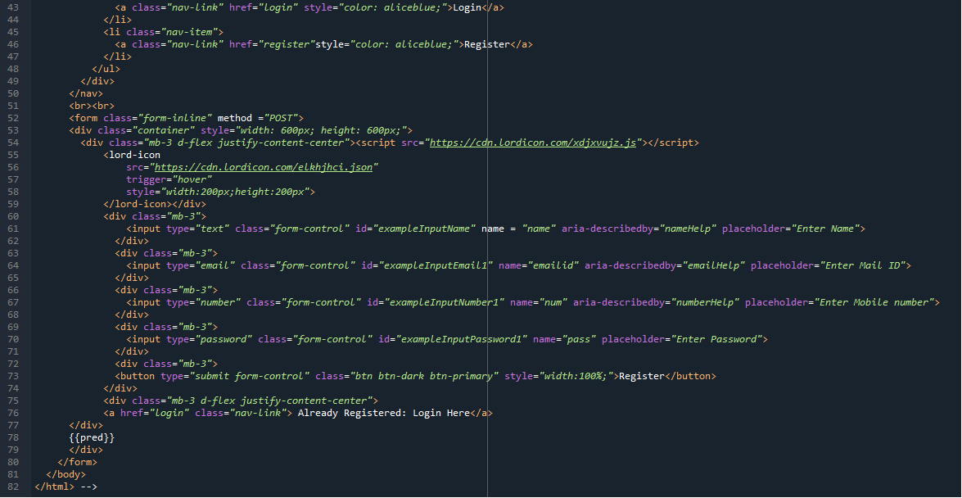

**LOGIN.HTML:**

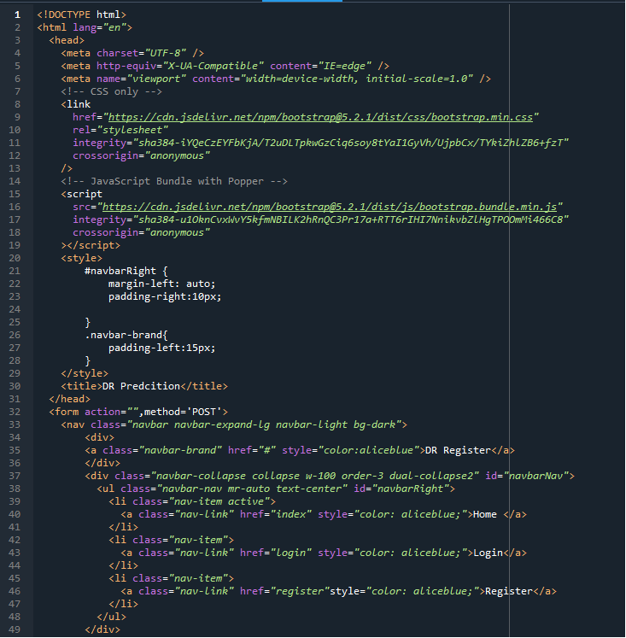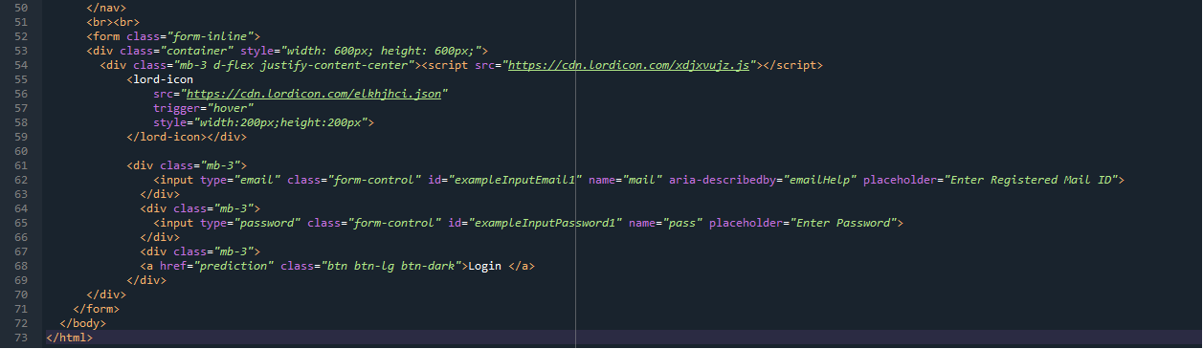

**PREDICTION.HTML:**

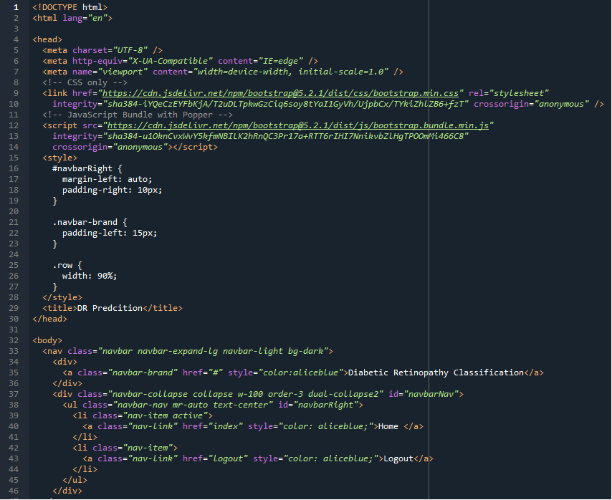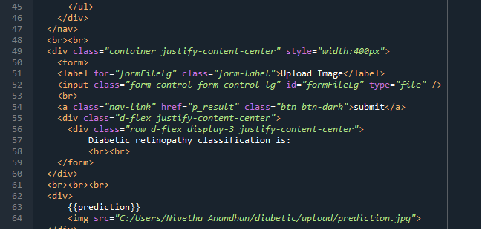

**LOGOUT.HTML:**

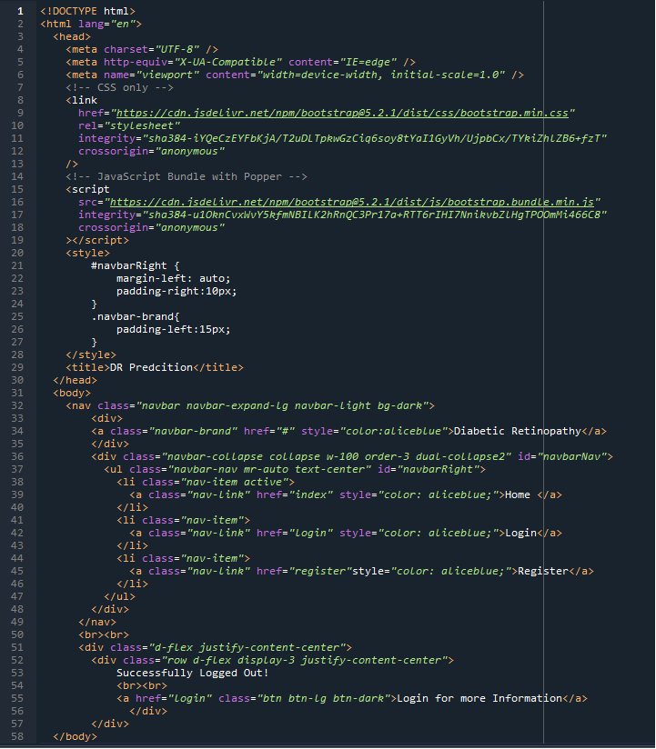

**APPLICATION:**

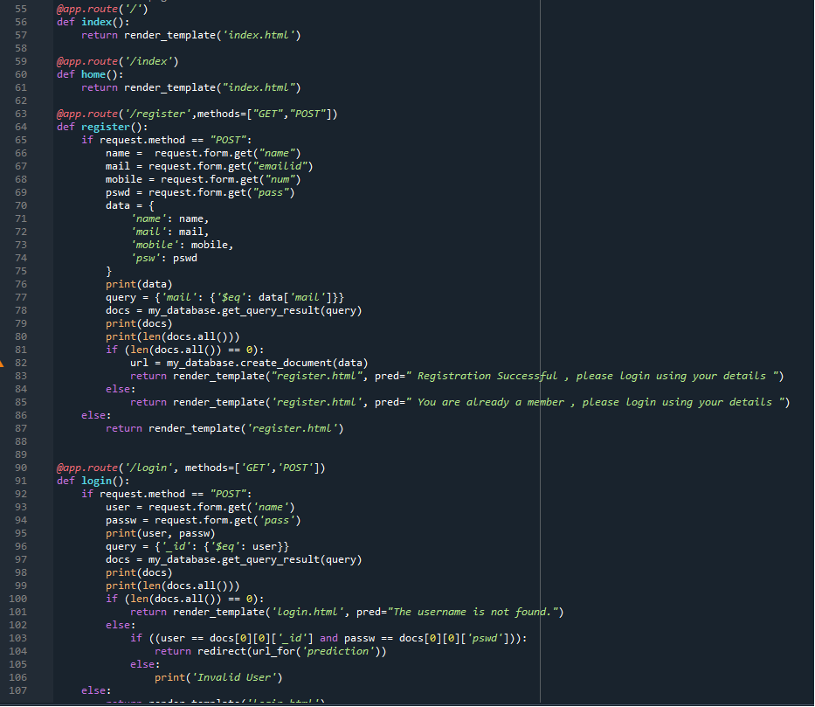

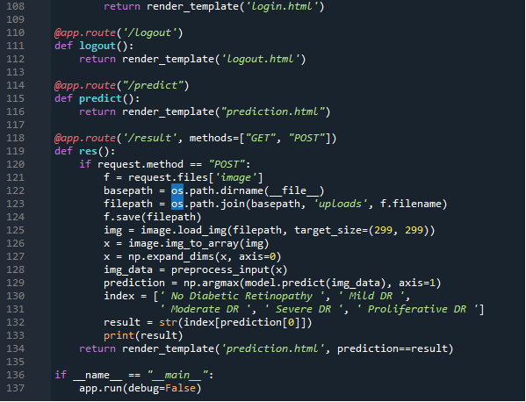

**GITHUB LINK:**

https://github.com/IBM-EPBL/IBM-Project-40133-1660623945

#### **PROJECT DEMO LINK:** https://drive.google.com/file/d/1sm3_2uAK2eWviRsfTdOuWg8CvySgMbR7/view?usp=drivesdk